Car-Insurance Company E-R Diagram

Phase 1: Data Requirements Analysis
Business Rules:
- Customers: Own one or more cars each
- Cars: Each car can have zero to many recorded accidents
- Accidents: Recorded incidents involving specific cars

Phase 2: Entity Set Design
Entity Sets Identified:
- Customer Entity Set
  - Attributes: customer-id (PK), customer-name, customer-address, customer-phone
  - Decision: Strong entity - exists independently with unique identification
- Car Entity Set
  - Attributes: car-id (PK), make, model, year, vin-number, license-plate
  - Decision: Strong entity - each car has unique identification
- Accident Entity Set
  - Attributes: accident-id (PK), accident-date, accident-location, damage-description, claim-amount
  - Decision: Strong entity - accidents are independent events with unique records

Phase 3: Relationship Set Design
Relationship Sets Identified:
- Owns (One-to-Many): Between Customer and Car
  - Cardinality: One customer owns many cars, each car owned by exactly one customer
  - Participation:
    - Customer: Partial (customer may own 0 cars initially)
    - Car: Total (every car must have an owner)
  - Attributes: purchase-date, insurance-policy-number
- Involved-In (One-to-Many): Between Car and Accident
  - Cardinality: One car can have many accidents, each accident involves exactly one car
  - Participation:
    - Car: Partial (car may have 0 accidents)
    - Accident: Total (every accident must involve a car)
  - Attributes: driver-at-fault, police-report-number

Complete E-R Diagram for Car-Insurance Company

Diagram Structure:
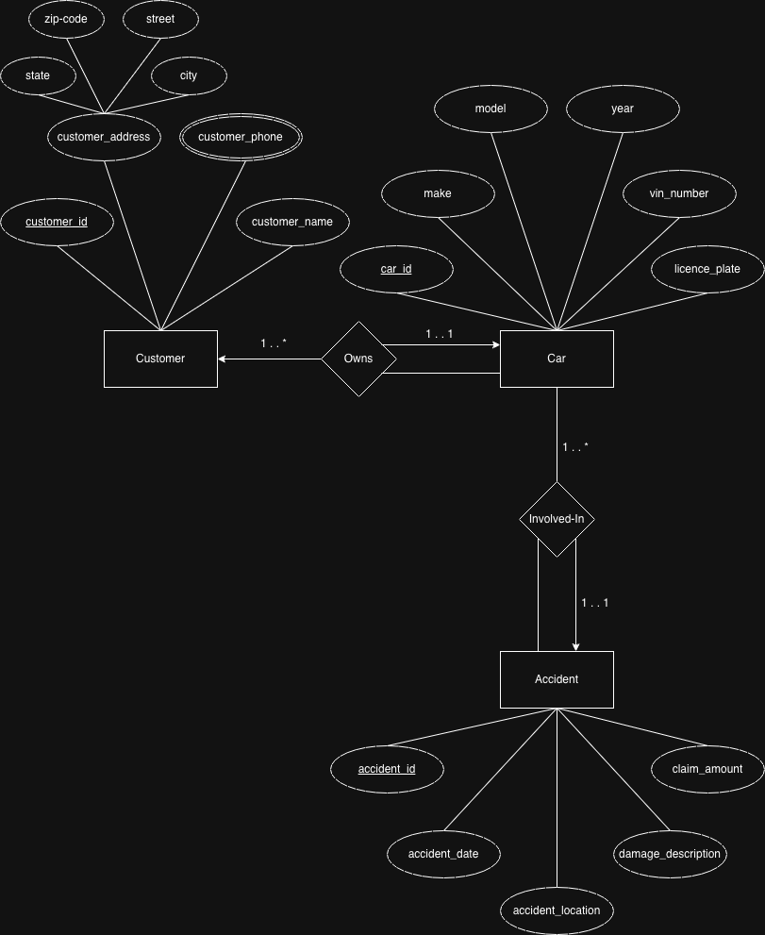

Detailed Specifications:
Entity Sets:
- Customer: Strong entity with customer-id as primary key
- Car: Strong entity with car-id as primary key
- Accident: Strong entity with accident-id as primary key
Relationship Sets:
- Owns: One-to-Many relationship (Customer → Car)
  - Total participation on Car side (every car has an owner)
  - Partial participation on Customer side (customer may own 0 cars)
  - Attributes: purchase-date, insurance-policy-number
- Involved-In: One-to-Many relationship (Car → Accident)
  - Total participation on Accident side (every accident involves a car)
  - Partial participation on Car side (car may have 0 accidents)
  - Attributes: driver-at-fault, police-report-number

